ASP.NET Core 8.0 Web API
Aim:
To implement the PUT action method in an ASP.NET Core Web API to update employee information, validate employee IDs, and test the API using Swagger.

Objectives:
- Demonstrate the implementation of the PUT action method.
- Demonstrate the use of the [FromBody] attribute to receive employee data.
- Validate employee IDs before updating employee information.
- Return appropriate HTTP responses using ActionResult.
- Test the Web API using Swagger.

Tools Used:
- Visual Studio 2026
- ASP.NET Core Web API (.NET 10)
- C#
- Swagger UI

Procedure:

Step 1: Modify EmployeeController
Added the PUT action method to the EmployeeController for updating employee information.

Step 2: Validate Employee ID
Validated the employee ID before updating the record. If the ID is invalid or not found in the employee list, the API returns 400 Bad Request with the message "Invalid employee id".

Step 3: Update Employee Details
Updated the employee information using the data received through the [FromBody] attribute and returned the updated employee object.

Step 4: Execute PUT Method
Executed the PUT /api/Employee/{id} endpoint using Swagger with a valid employee ID.
Verified that the API returned the updated employee details with HTTP Status Code 200 (OK).

Step 5: Test Invalid Employee ID
Executed the PUT method using an invalid employee ID.
Verified that the API returned HTTP Status Code 400 (Bad Request) with the message "Invalid employee id".
HTTP Method | Purpose
PUT | Update existing employee data

Figure 1: EmployeeController showing the PUT action method.
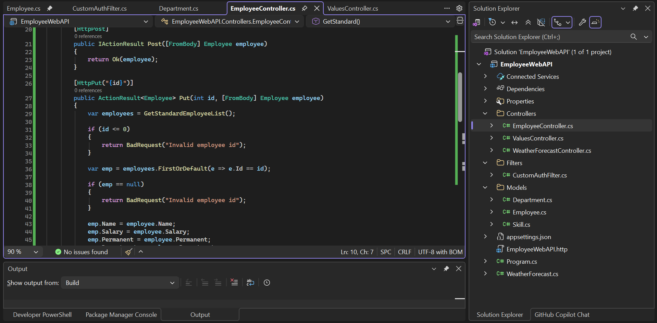

Figure 2: Swagger Home Page displaying the PUT endpoint.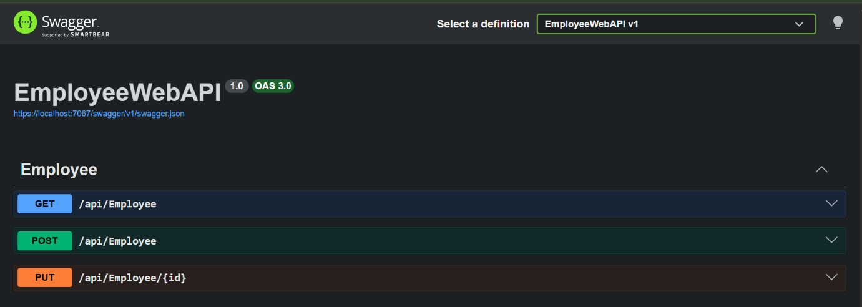

Figure 3: Swagger PUT response showing updated employee information with HTTP Status Code 200 (OK).
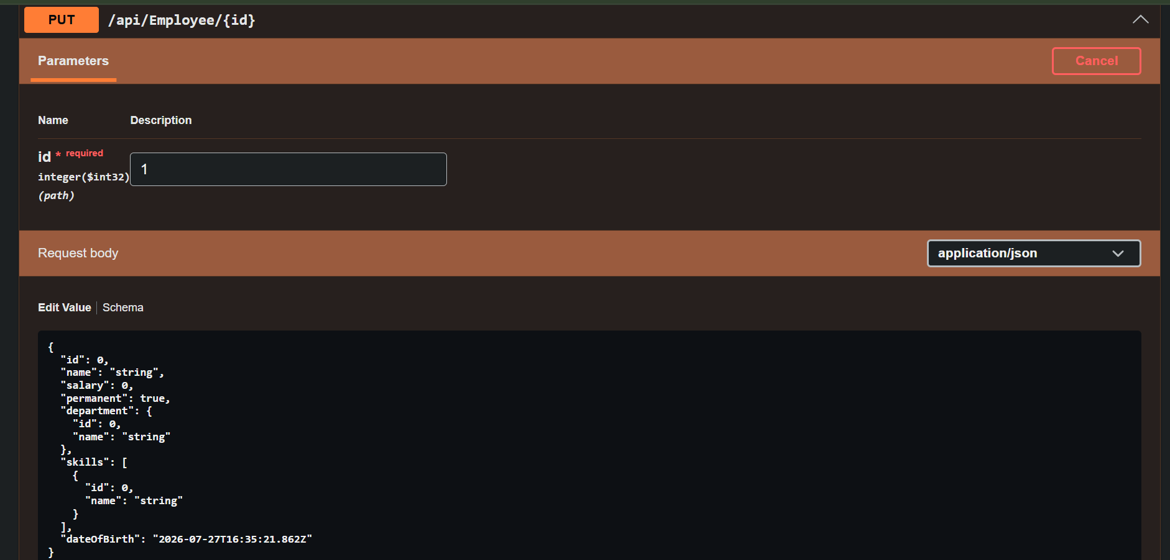

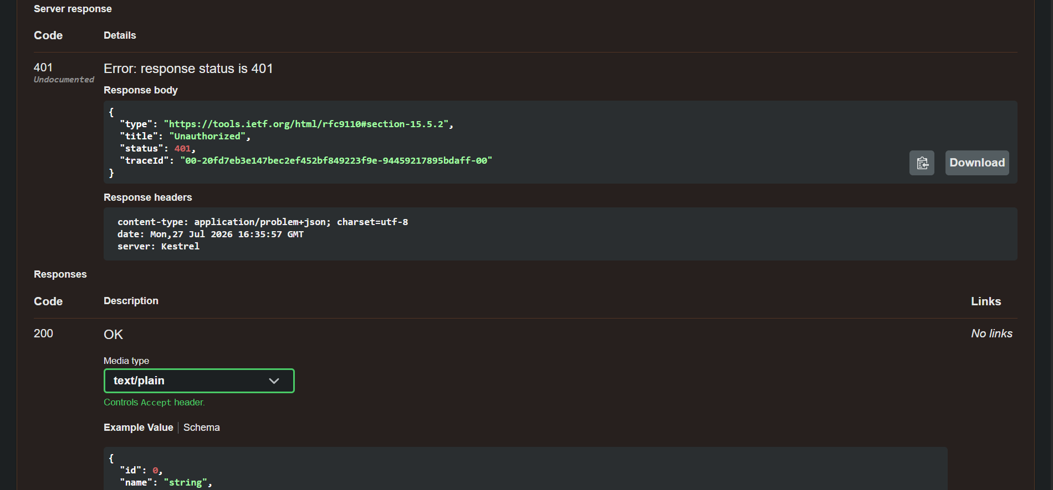

Figure 5: Swagger PUT response showing HTTP Status Code 400 (Bad Request) for an invalid employee ID.
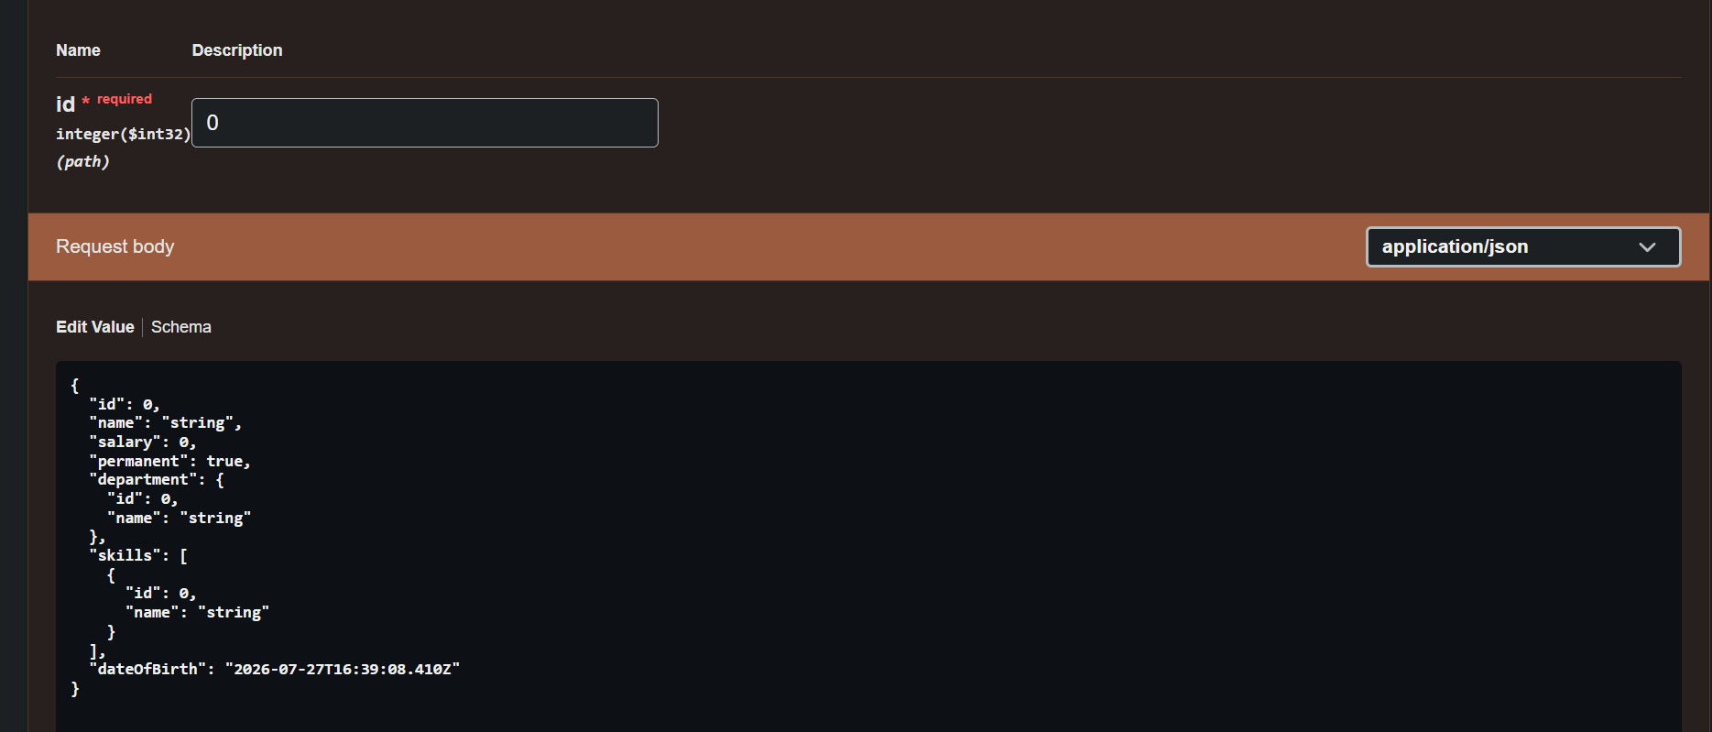

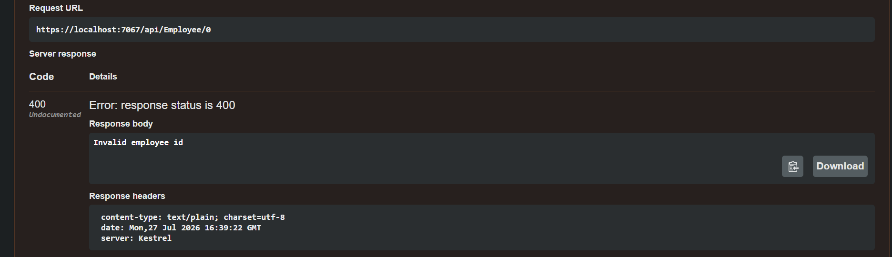

Result:
Successfully implemented the PUT action method to update employee information in the ASP.NET Core Web API. The API validated employee IDs, updated valid employee records, and returned the updated employee details. Invalid employee IDs returned HTTP Status Code 400 (Bad Request) with the message "Invalid employee id", confirming successful validation.

